**UNIT-II**

**CLOUD COMPUTING FUNDAMENTALS**

**Cloud Computing Fundamentals**: Motivation for Cloud Computing, The Need for Cloud Computing, Defining Cloud Computing, Definition of Cloud computing, Cloud Computing Is a Service, Cloud Computing Is a Platform, Principles of Cloud computing, Five Essential Characteristics, Four Cloud Deployment Models

Motivation for Cloud Computing

The users who are in need of computing are expected to invest money on computing resources such as hardware, software, networking, and storage; this investment naturally costs a bulk currency to the users as they have to buy these computing resources, keep these in their premises, and maintain and make it operational—all these tasks would add cost.

cloud computing is a mechanism of bringing–hiring or getting the services of the computing power or infrastructure to an organizational or individual level to the extent required and paying only for the consumed services.

Therefore, cloud computing is needed in getting the services of computing resources. Thus, one can say as a one-line answer to the need for cloud computing that it eliminates a large computing investment without compromising the use of computing at the user level at an operational cost. Cloud computing is very economical and saves a lot of money.

The cloud represents the Internet-based computing resources, and the accessibility is through some

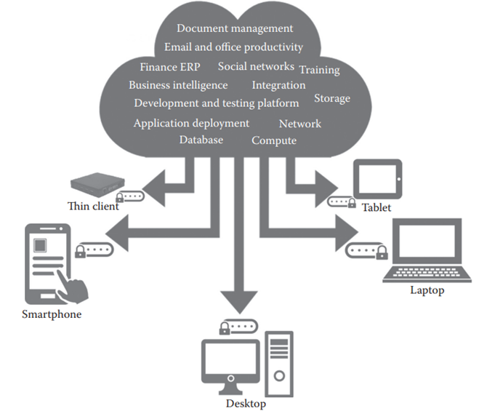

**The Need for Cloud Computing**

The main reasons for the need and use of cloud computing are convenience and reliability. In the past, if we wanted to bring a file, we would have to save it to a Universal Serial Bus (USB) flash drive, external hard drive, or compact disc (CD) and bring that device to a different place

While using the cloud, losing our data/file is much less likely. However, just like anything online, there is always a risk that someone may try to gain access to our personal data, and therefore, it is important to choose an access control with a strong password and pay attention to any privacy settings for the cloud service that we are using.

**Defining Cloud Computing**

Cloud computing means storing and accessing data and programs over the Internet from a remote location or computer instead of our computer’s hard drive. This so called remote location has several properties such as scalability, elasticity etc., which is significantly different from a simple remote machine.

The cloud is just a metaphor for the Internet. When we store data on or run a program from the local computer’s hard drive, that is called local storage and computing.

**NIST Definition of Cloud Computing**

Cloud computing is a model for enabling ubiquitous, convenient, on-demand network access to a shared pool of configurable computing resources (e.g., networks, servers, storage, applications, and services) that can be rapidly provisioned and released with minimal management effort or service provider interaction.

**Cloud Computing Is a Service**

Computer does is allow us to store and retrieve information. We can store our family photographs, our favorite songs, or even save movies on it, which is also the most basic service offered by cloud computing.

While Flickr started with an emphasis on sharing photos and images, it has emerged as a great place to store those images. In many ways, it is superior to storing the images on your computer:

1. First, Flickr allows us to easily access our images no matter where we are or what type of device we are using. While we might upload the photos of our vacation from our home computer, later, we can easily access them from our laptop at the office.
2. 2. Second, Flickr lets us share the images. There is no need to burn them to a CD or save them on a flash drive. We can just send someone our Flickr address to share these photos or images.
3. Third, Flickr provides data security. By uploading the images to Flickr, we are providing ourselves with data security by creating a backup on the web. And, while it is always best to keep a local copy— either on a computer, a CD, or a flash drive—the truth is that we are far more likely to lose the images that we store locally than Flickr is of losing our image.

**Cloud Computing Is a Platform**

The World Wide Web (WWW) can be considered as the operating system for all our Internet-based applications. However, one has to understand that we will always need a local operating system in our computer to access webbased application

The basic meaning of the term platform is that it is the support on which applications run or give results to the users. For example, Microsoft Windows is a platform. But, a platform does not have to be an operating system. Java is a platform even though it is not an operating system.

cloud computing, the web is becoming a platform.

With trends (applications) such as Office 2.0, more and more applications that were originally available on desktop computers are now being converted into web–cloud applications. Word processors like Buzzword and office suites like Google Docs are now available in the cloud as their desktop counterparts. All these kinds of trends in providing applications via the cloud are turning cloud computing into a platform or to act as a platform.

**5-4-3 Principles of Cloud computing**

The 5-4-3 principles put forth by NIST describe (a) the five essential characteristic features that promote cloud computing, (b) the four deployment models that are used to narrate the cloud computing opportunities for customers while looking at architectural models, and (c) the three important and basic service offering models of cloud computing.

**Five Essential Characteristics**

Cloud computing has five essential characteristics, which are shown in Figure 2.2. Readers can note the word essential, which means that if any of these characteristics is missing, then it is not cloud computing:

1. On-demand self-service: A consumer can unilaterally provision computing capabilities, such as server time and network storage, as needed automatically without requiring human interaction with each service’s provider.

2. Broad network access: Capabilities are available over the network and accessed through standard mechanisms that promote use by heterogenerous thin or thick client platforms (e.g., mobile phones, laptops, and personal digital assistants [PDAs]).

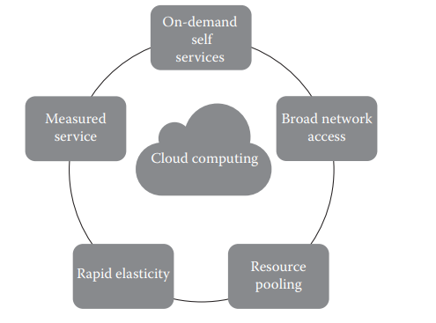

3. Elastic resource pooling: The provider’s computing resources are pooled to serve multiple consumers using a multitenant model, with different physical and virtual resources dynamically assigned and reassigned according to consumer demand. There is a sense of location independence in that the customer generally has no control or knowledge over the exact location of the provided resources but may be able to specify the location at a higher level of abstraction (e.g., country, state, or data center). Examples of resources include storage, processing, memory, and network bandwidth.

4. Rapid elasticity: Capabilities can be rapidly and elastically provisioned, in some cases automatically, to quickly scale out and rapidly released to quickly scale in. To the consumer, the capabilities available for provisioning often appear to be unlimited and can be purchased in any quantity at any time.

5. Measured service: Cloud systems automatically control and optimize resource use by leveraging a metering capability at some level of abstraction appropriate to the type of service (e.g., storage, processing, bandwidth, and active user accounts). Resource usage can be monitored, controlled, and reported providing transparency for both the provider and consumer of the utilized service.

**Four Cloud Deployment Models**

Four deployment models are usually distinguished, namely, public, private, community, and hybrid cloud service usage:

1. Private cloud: The cloud infrastructure is provisioned for exclusive use by a single organization comprising multiple consumers (e.g., business units). It may be owned, managed, and operated by the organization, a third party, or some combination of them, and it may exist on or off premises.

2. Public cloud: The cloud infrastructure is provisioned for open use by the general public. It may be owned, managed, and operated by a business, academic, or government organization, or some combination of them. It exists on the premises of the cloud provider.

3. Community cloud: The cloud infrastructure is shared by several organizations and supports a specific community that has shared concerns (e.g., mission, security requirements, policy, and compliance considerations). It may be managed by the organizations or a third party and may exist on premise or off premise.

4. Hybrid cloud: The cloud infrastructure is a composition of two or more distinct cloud infrastructures (private, community, or public) that remain unique entities but are bound together by standardized or proprietary technology that enables data and application portability (e.g., cloud bursting for load balancing between clouds)